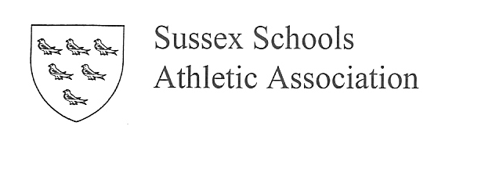
October 2014

Dear Colleague,

I am writing to you and your school to ask for the annual affiliation fee to Sussex Schools Athletics Association for 2014/2015. The affiliation fee is £40 (or £20 for Middle schools with pupils up to year 8 only). Your fee is important to the future of athletes and athletics in Sussex Schools. Your payment allows;

- Athletes from schools to compete at cross-country and track and field competitions staged by the association.
- Athletes to represent their county in competitions at a regional and national level.
- Athletes to receive the best support in training for competitions and through top quality team management.
- Athletes and schools to stay up to date with information via our website at www.sussexathletics.org (follow link to Sussex Schools AA).
- Schools to be notified via an annual newsletter about championships and the future of SSAA.

Sussex has recently been upgraded to an A county by the English Schools AA, which increases our expense. The Association is run by volunteers and without affiliation income would not be able to continue.

Please complete the following information form and send with the affiliation fee of £40 to the treasurer of the SSAA:
Martin Etchells, Treasurer SSAA, ‘La Chata’, Guardswell Place, Seaford, BN25 1SD.

Payment can also be made by BACS to Lloyds TSB Bank, sort code 30-95-01, Account No 03151181

Thanking you in advance for your support.

Becci Camis
(Secretary- SSAA)
Affiliation Fees 2014/2015

School:

Address:

Post Code:

Telephone: Fax:

Headteacher/Principal:

Area of School: (Please circle)

Brighton and Hove, South Downs, Mid Sussex, Ouse Valley, West Sussex West, West Sussex South, Hastings and Rother, Crawley

Head of PE:................................ Email:....................................
Payment (please tick one):

I enclose a cheque (payable to SSAA) [ ]
OR

Payment has been made by BACS (Lloyds TSB Bank, 30-95-01, Account No 03151181) [ ]

Signed: Date:

